Project Design Phase-II
Data Flow Diagram & User Stories

Date | 30 September 2026
Team ID | SWTID-2026-6606
Project Name | AI FitTrack API
Maximum Marks | 4 Marks

Data Flow Diagrams:
A Data Flow Diagram (DFD) is a traditional visual representation of the information flows within a system. A neat and clear DFD can depict the right amount of the system requirement graphically. It shows how data enters and leaves the system, what changes the information, and where data is stored.
Example: DFD Level 0 (Industry Standard)
Example: (Simplified)


Data Flow Diagram – AI FitTrack API
Level 0 (context diagram): shows the system with its external entities.
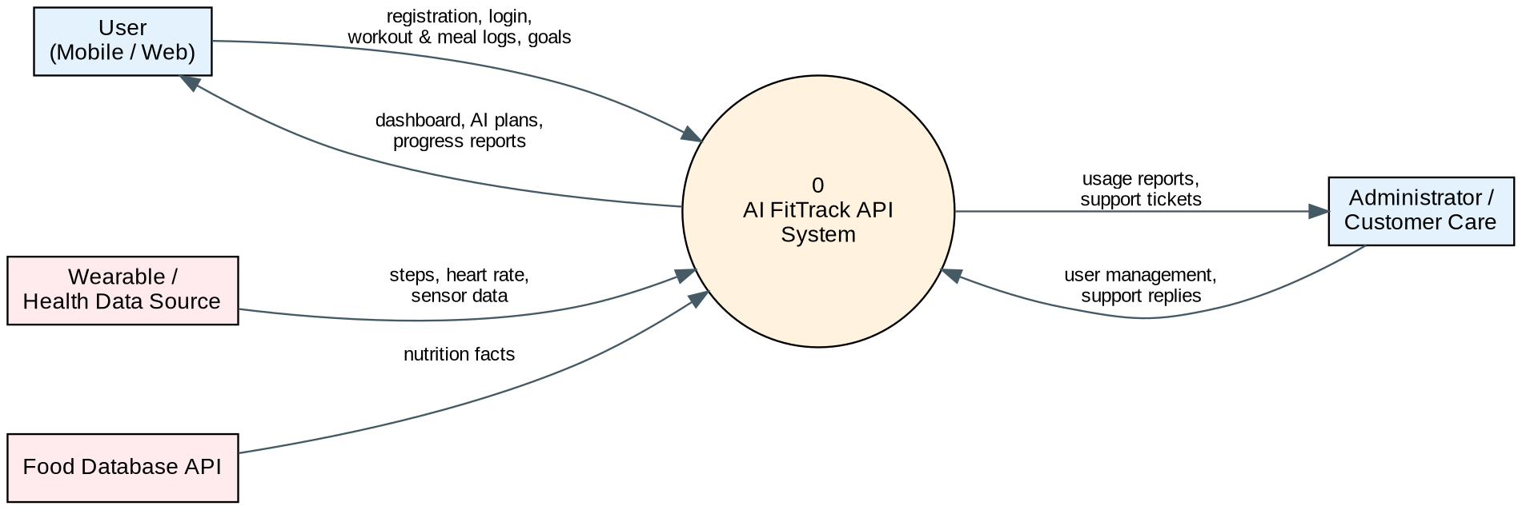
Level 1: shows the main processes, data stores and data flows.
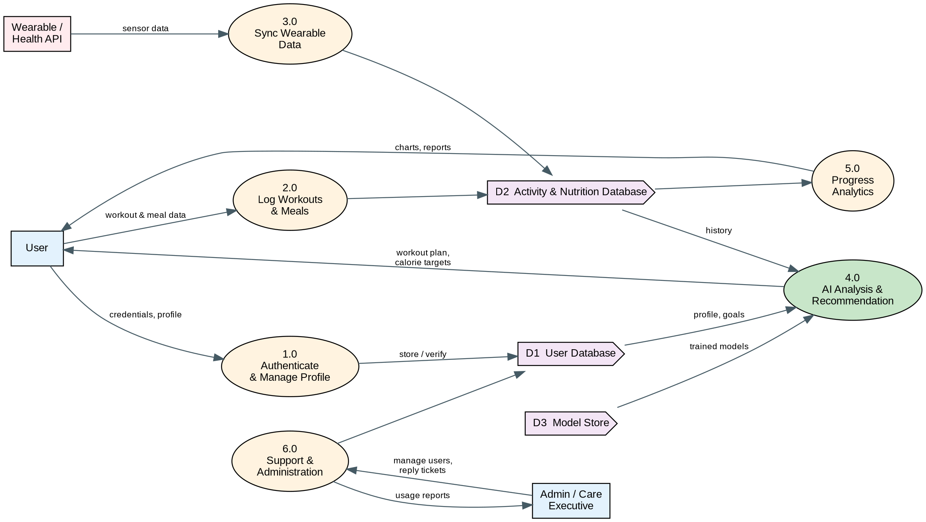

User Stories
Use the below template to list all the user stories for the product.
User Type | Functional Requirement (Epic) | User Story Number | User Story / Task | Acceptance criteria | Priority | Release
Customer (Mobile user) | Registration | USN-1 | As a user, I can register for the application by entering my email, password, and confirming my password. | I can create an account and access my dashboard | High | Sprint-1
 |  | USN-2 | As a user, I will receive a confirmation email once I have registered for the application. | I receive the confirmation email and can click confirm | High | Sprint-1
 |  | USN-3 | As a user, I can register for the application through Gmail. | I can register and access the dashboard with Google sign-in | Medium | Sprint-1
 | Login | USN-4 | As a user, I can log into the application by entering email and password. | I receive a valid JWT token and can open my dashboard | High | Sprint-1
 |  | USN-5 | As a user, I can reset my password through an emailed link or OTP. | I can set a new password and log in with it | Medium | Sprint-1
 | Profile | USN-6 | As a user, I can create my profile with age, height, weight and fitness goal. | My profile is saved and can be edited later | High | Sprint-1
 | Workout Logging | USN-7 | As a user, I can log a workout (type, duration, sets, reps) through the API. | The workout is stored and appears in my history | High | Sprint-1
 |  | USN-8 | As a user, I can view, edit and delete my workout history. | I can see all my past workouts and change or remove them | High | Sprint-1
 | Dashboard | USN-9 | As a user, I can view a daily summary of my workouts, calories and steps on my dashboard. | The dashboard shows today's totals correctly | High | Sprint-1
 | Nutrition Tracking | USN-10 | As a user, I can log my meals and see the calories and macros consumed. | Meals are saved and daily totals are calculated | High | Sprint-2
 |  | USN-11 | As a user, I can search a food database to add items quickly. | Search returns food items with nutrition values | Medium | Sprint-2
 | Wearable Integration | USN-12 | As a user, I can connect my wearable / Google Fit account so that steps and heart rate sync automatically. | My steps and heart rate appear on the dashboard without manual entry | Medium | Sprint-2
 | AI Recommendations | USN-13 | As a user, I receive a personalised weekly workout plan based on my profile and history. | A weekly plan matching my goal is returned and refreshed each week | High | Sprint-2
 |  | USN-14 | As a user, I receive daily calorie and macro targets based on my goal. | Targets are shown and change when my weight or goal changes | High | Sprint-2
 | AI Recommendations | USN-15 | As a user, my activities (walking, running, cycling) are recognised automatically from sensor data. | Detected activities are listed with time and duration | Medium | Sprint-3
Customer (Web user) | Progress Analytics | USN-16 | As a user, I can view weekly and monthly progress charts. | Charts show workouts, calories and weight trends for the chosen period | High | Sprint-3
 |  | USN-17 | As a user, I can set goals and track how close I am to achieving them. | Goal progress is shown as a percentage | Medium | Sprint-3
Customer (Mobile user) | Notifications | USN-18 | As a user, I receive reminders and achievement notifications. | I receive a reminder at my chosen time and a message when a goal is met | Low | Sprint-3
Customer (Web user) | Customer Support | USN-19 | As a user, I can raise a support ticket when I face a problem. | A ticket number is generated and I can see its status | Medium | Sprint-3
Customer Care Executive |  | USN-20 | As a customer care executive, I can view and respond to support tickets. | I can open, reply to and close tickets | Medium | Sprint-3
Administrator | User Management | USN-21 | As an administrator, I can view, block or delete user accounts. | Changes to accounts take effect immediately | High | Sprint-4
 | Monitoring | USN-22 | As an administrator, I can monitor API usage and AI model performance. | Usage and accuracy reports are shown on the admin dashboard | Medium | Sprint-4
Customer (Web user) | Web Dashboard | USN-23 | As a user, I can use all main features from a web dashboard in my browser. | Web dashboard supports login, logging, plans and charts | High | Sprint-4
Administrator | API Access | USN-24 | As a developer, I can get an API key and I am protected by rate limiting. | A valid key is required and requests above the limit are rejected | Medium | Sprint-4
 | Deployment | USN-25 | As a team, we deploy the API to the cloud with Swagger documentation. | The API is reachable online and its documentation is available | High | Sprint-4

